

***INSTITUTE OF INFORMATION TECHNOLOGY***

***JAHANGIRNAGAR UNIVERSITY***

**Number of Assignment :** 01

**Submission Date :** 14/07/2021

**Course Tittle :** Discrete Mathematics

**Course Code :** ICT – 1207

**Submitted To Submitted By**

Dr. M. Mesbahuddin Sarker Md. Shakil Hossain

Professor Class Roll – 2023

IIT – JU Exam Roll – 192340

IIT – JU

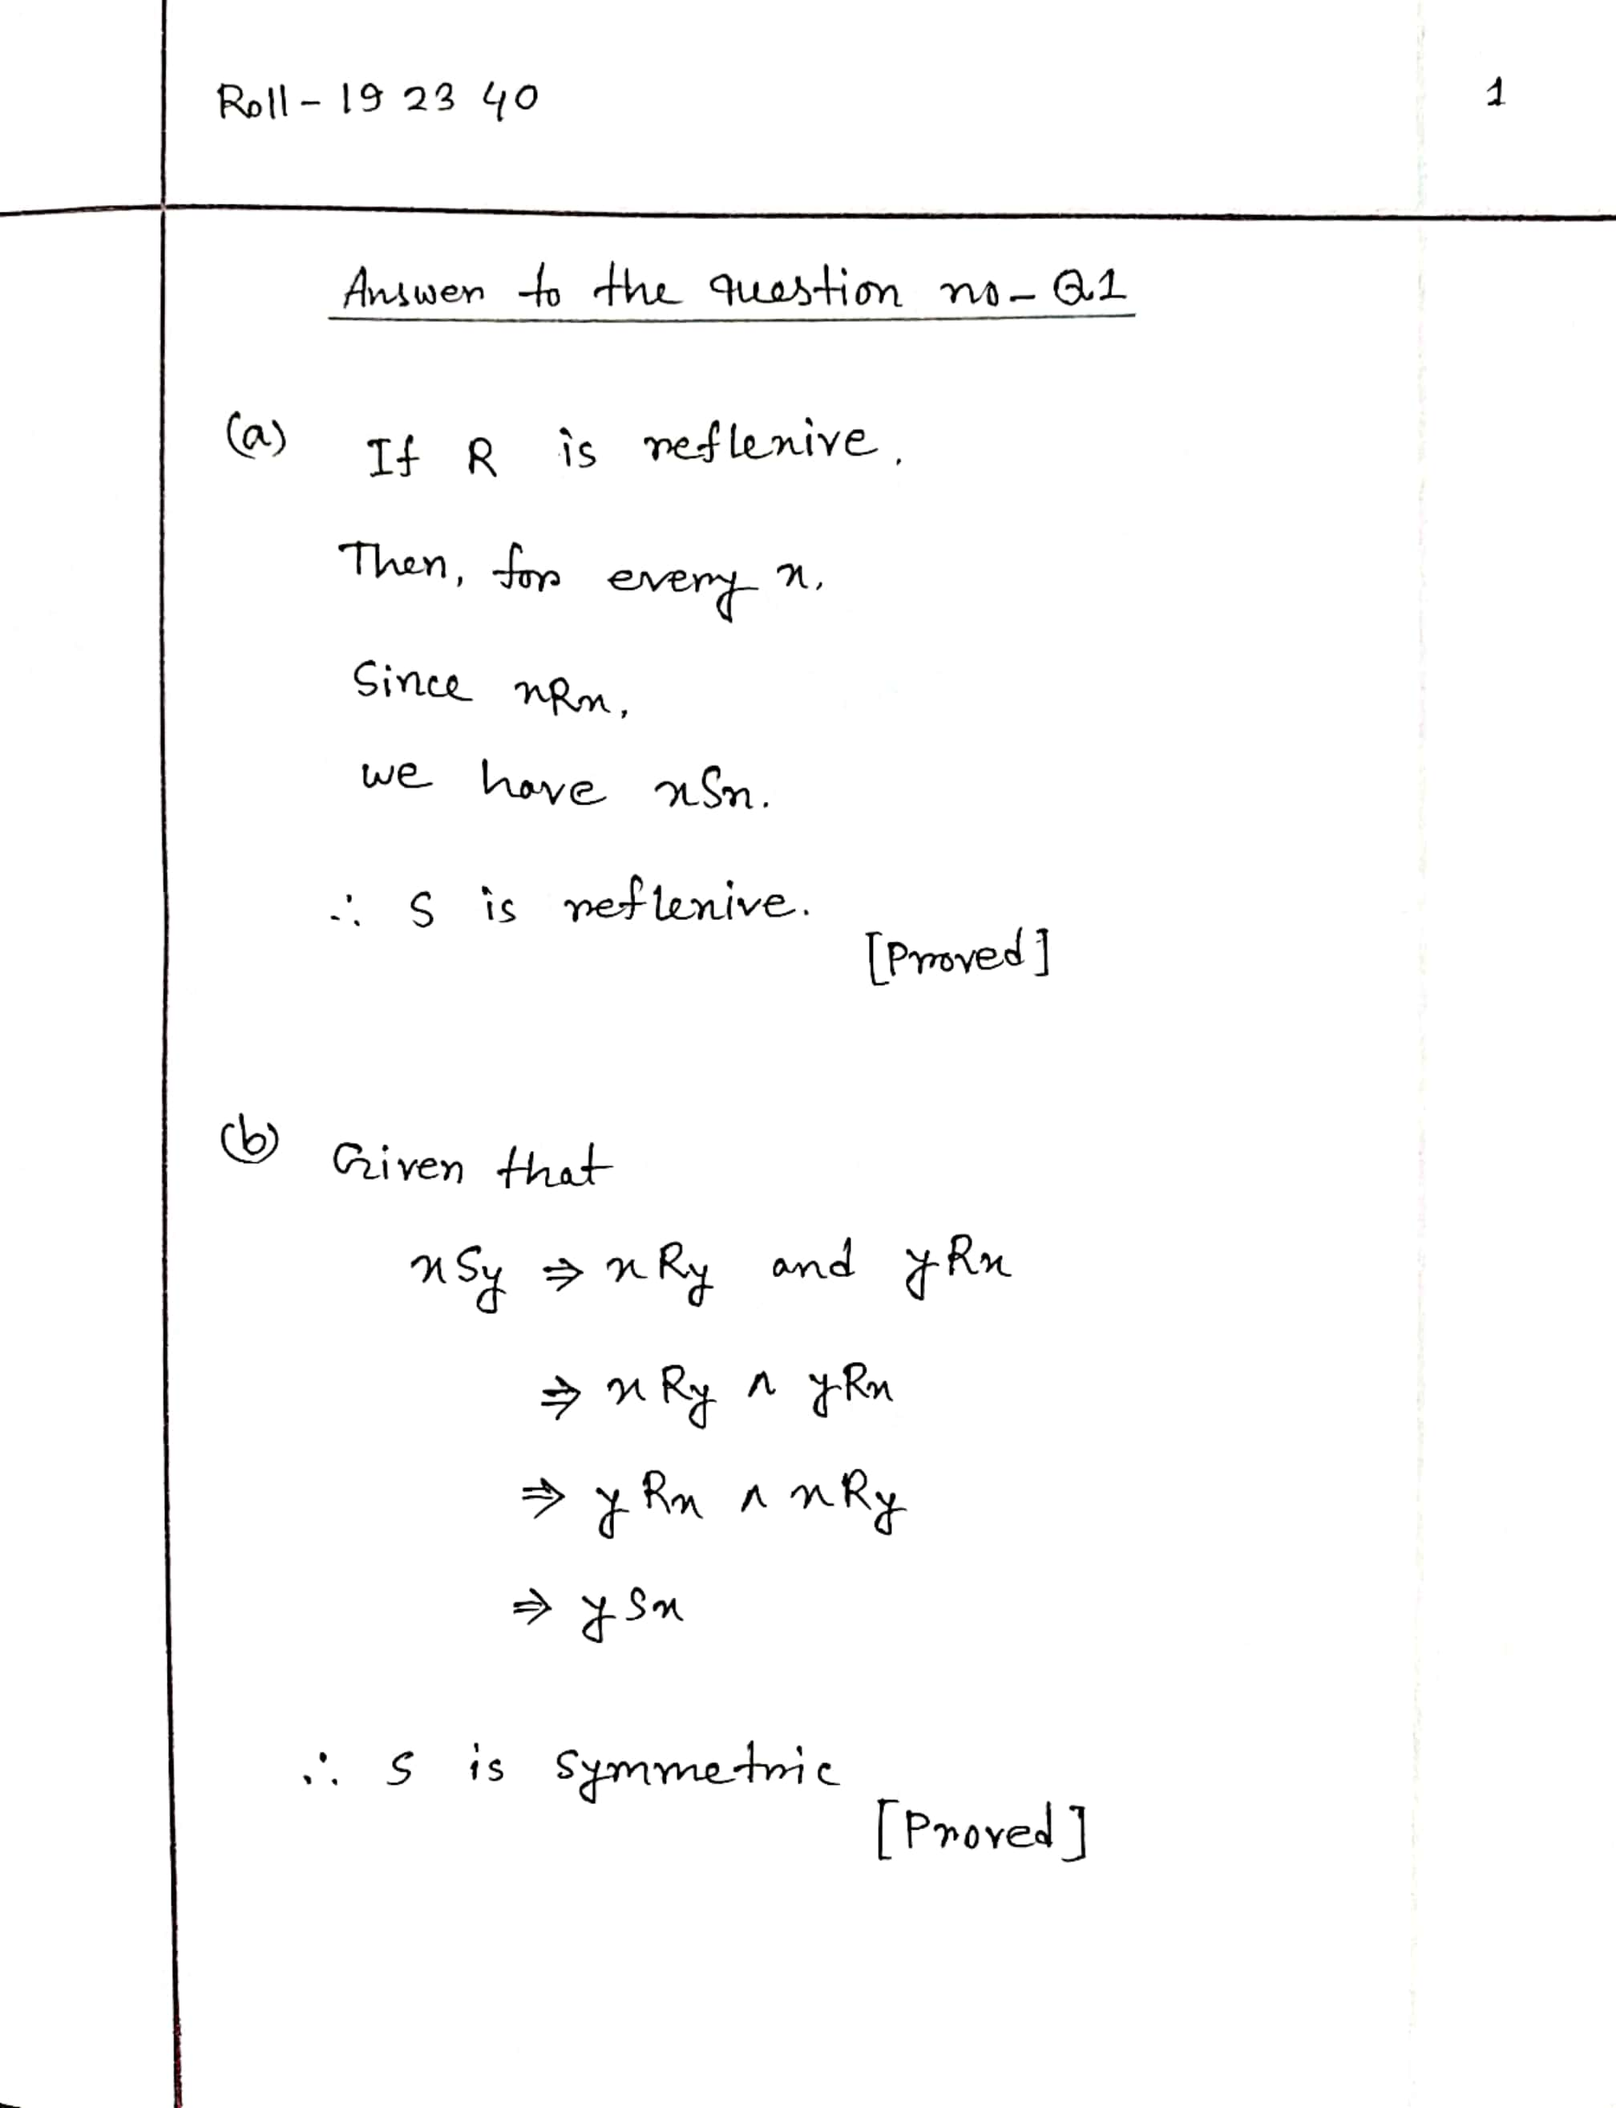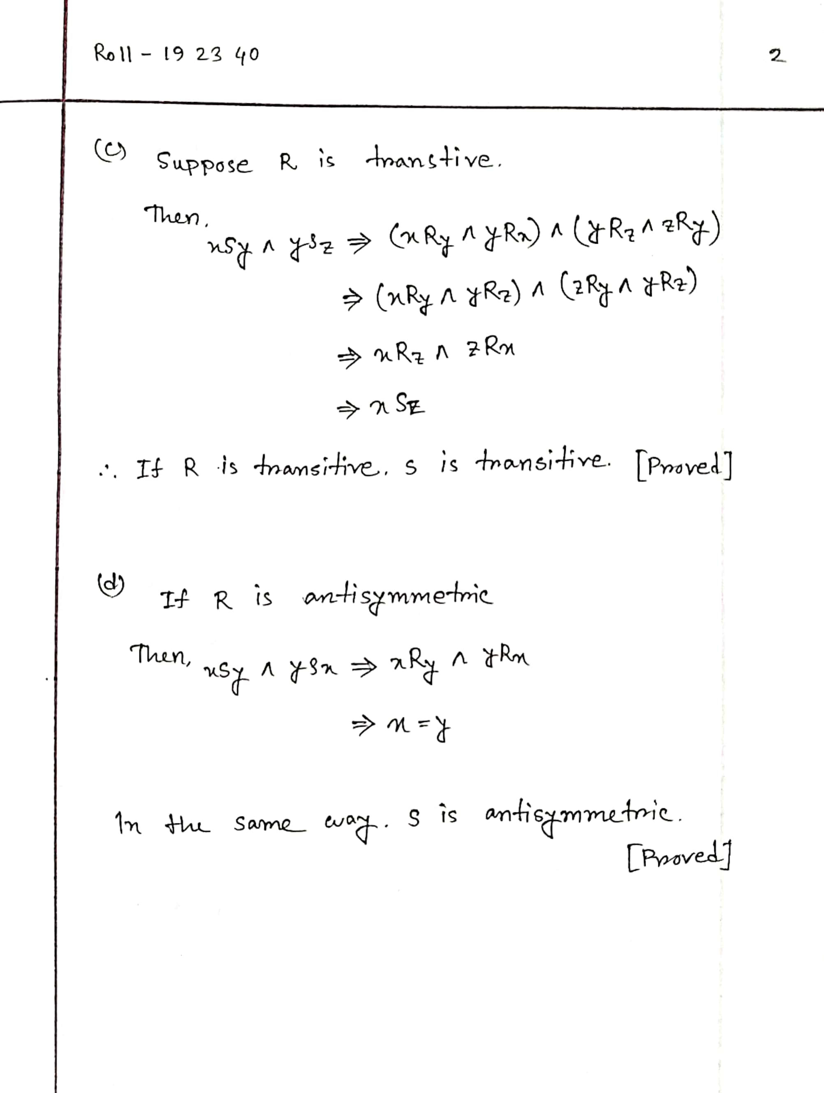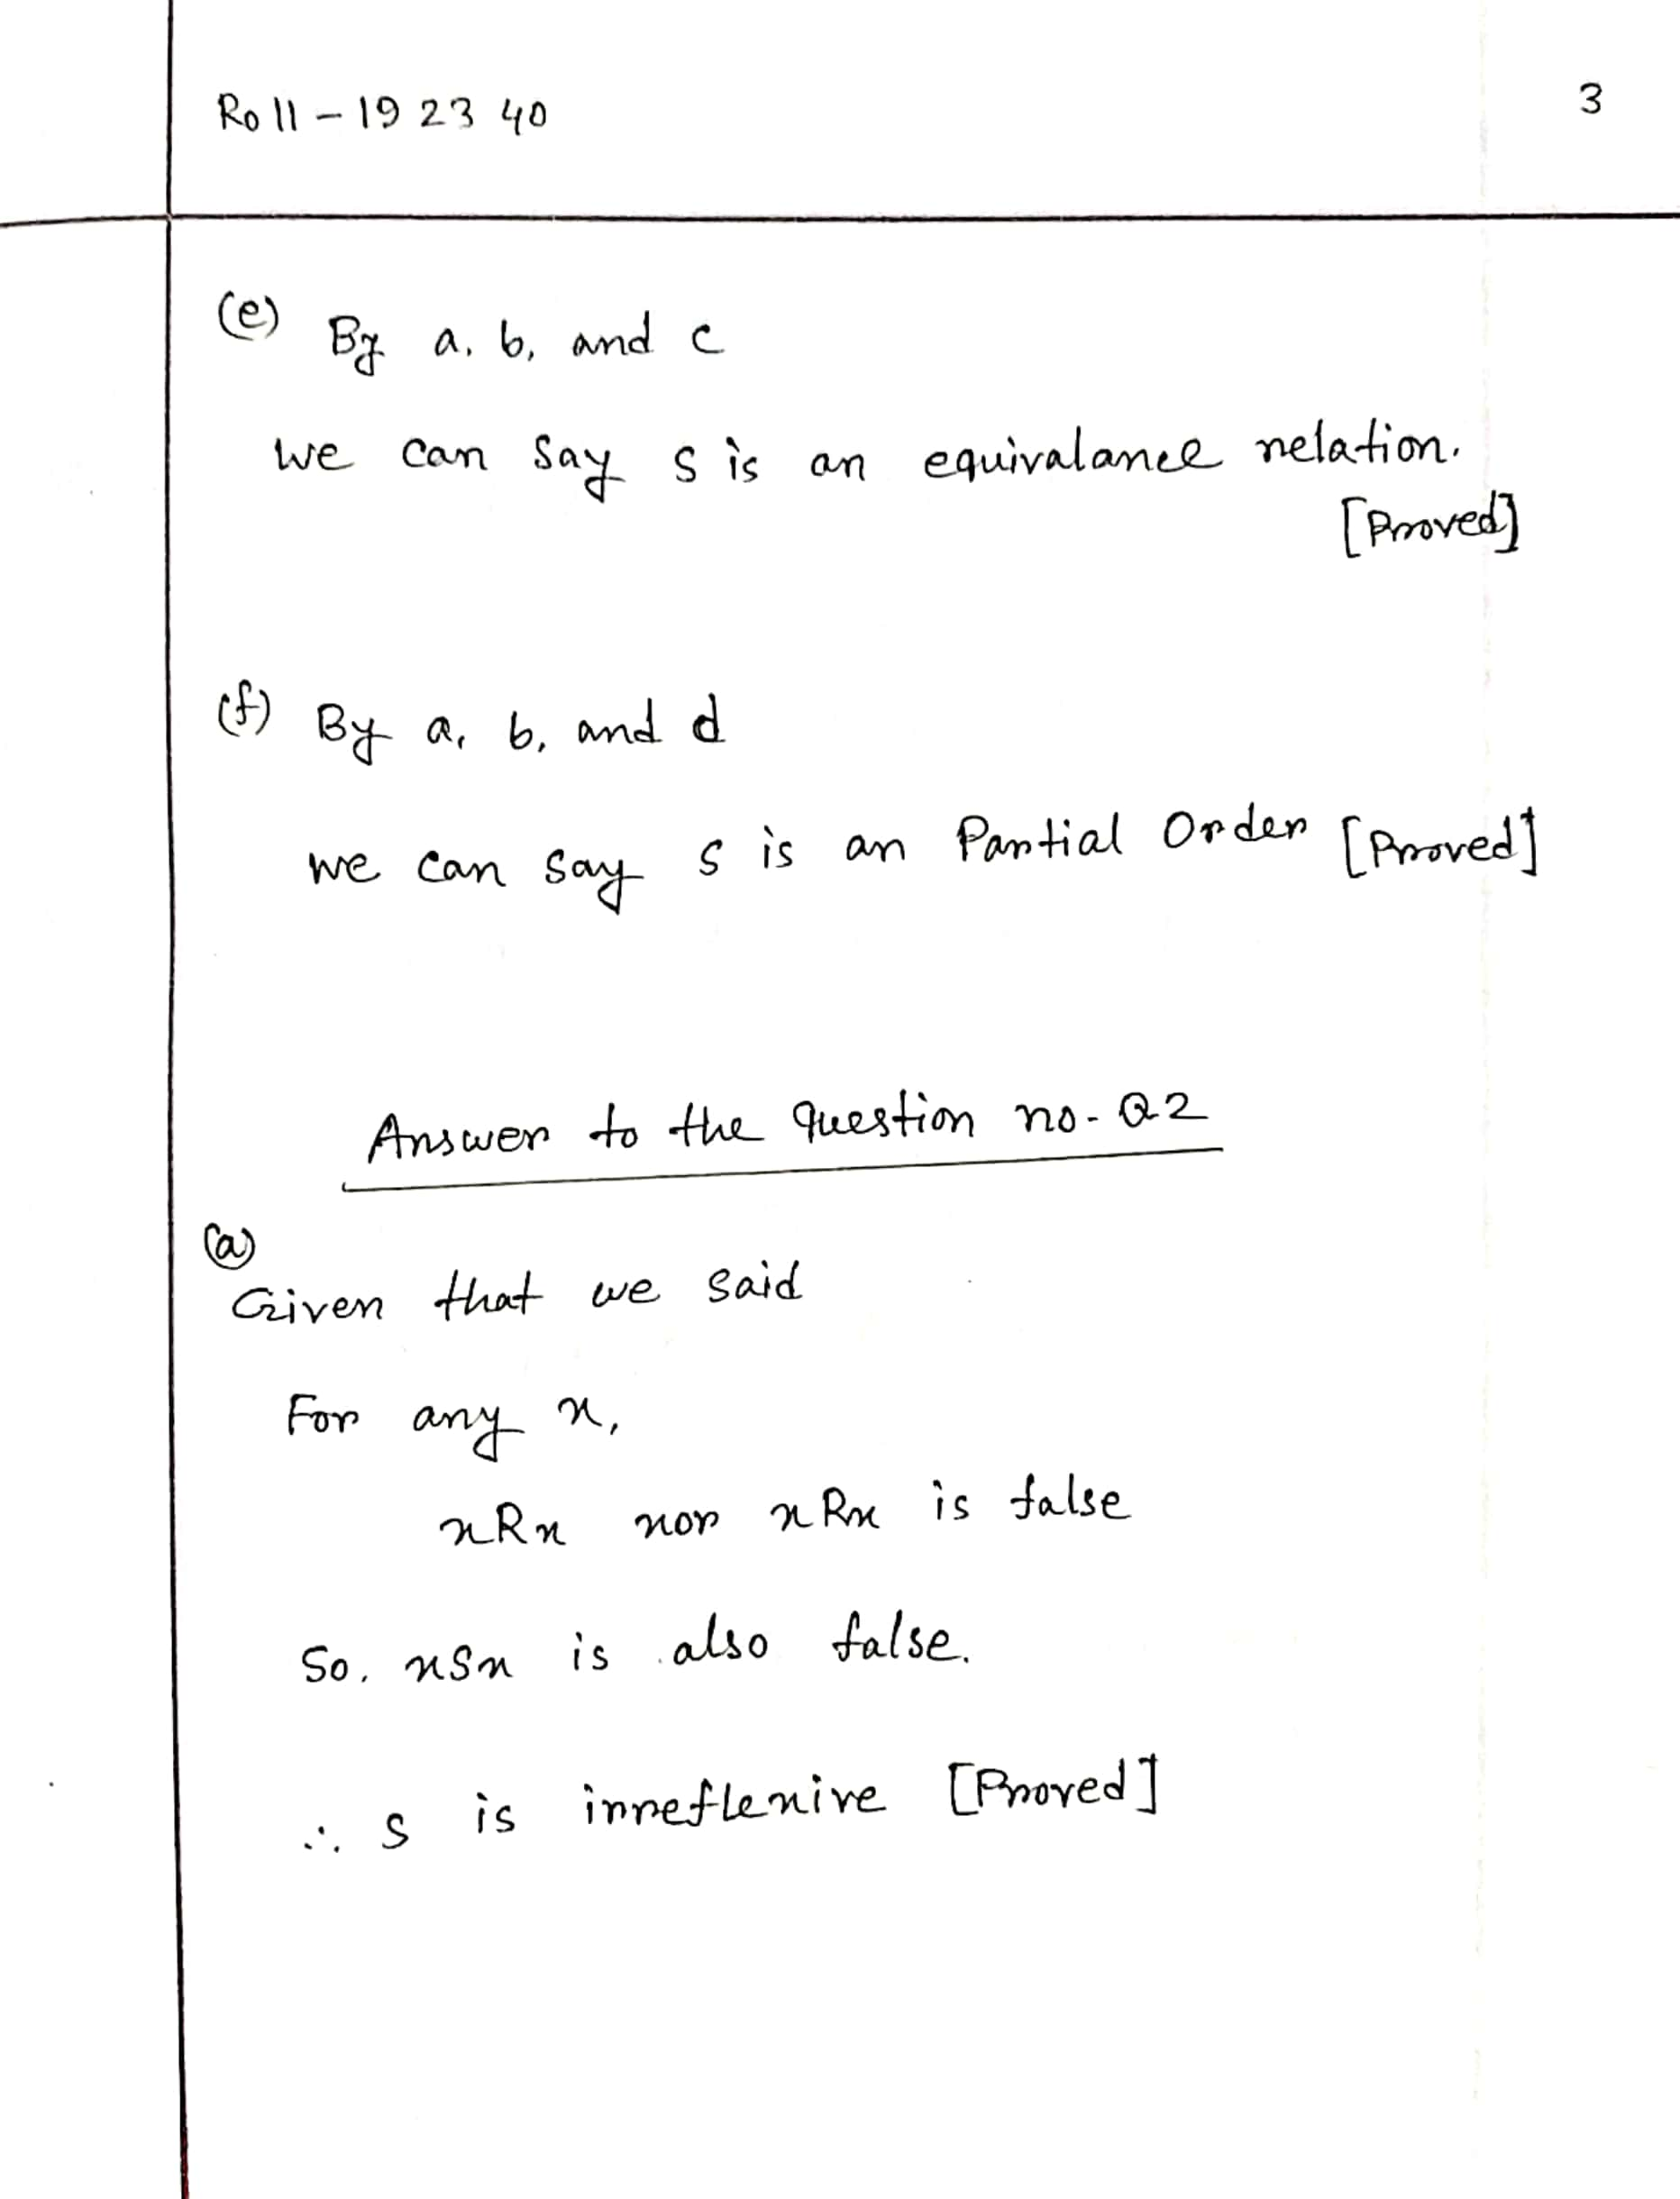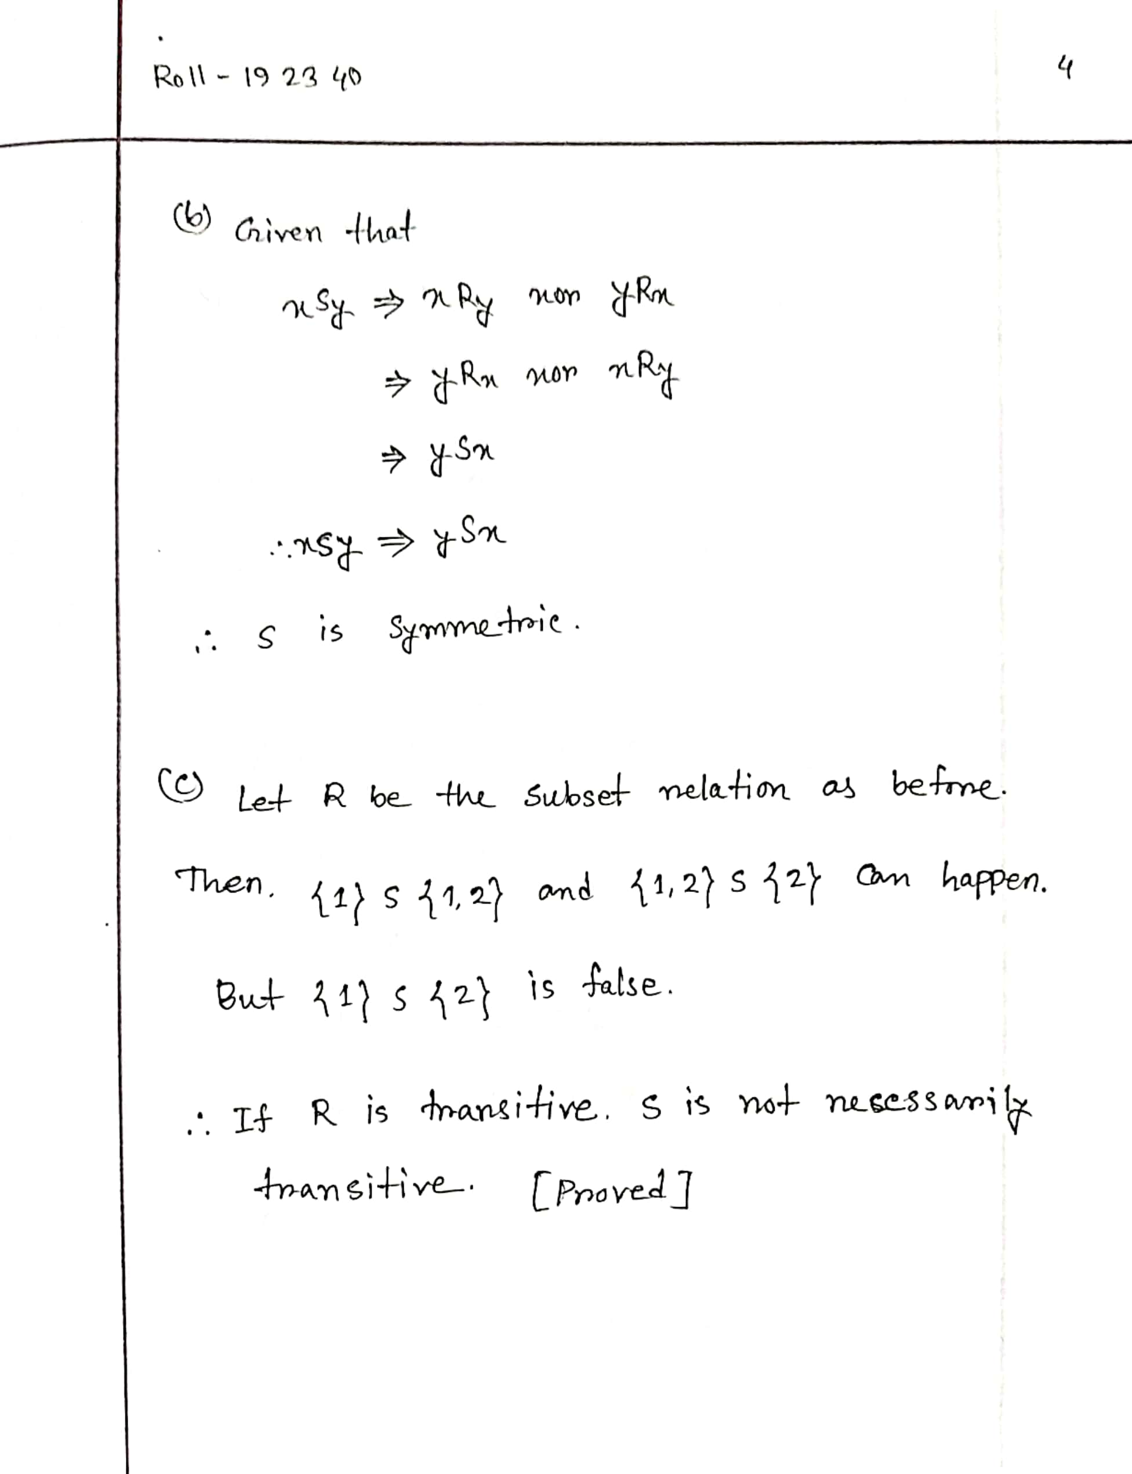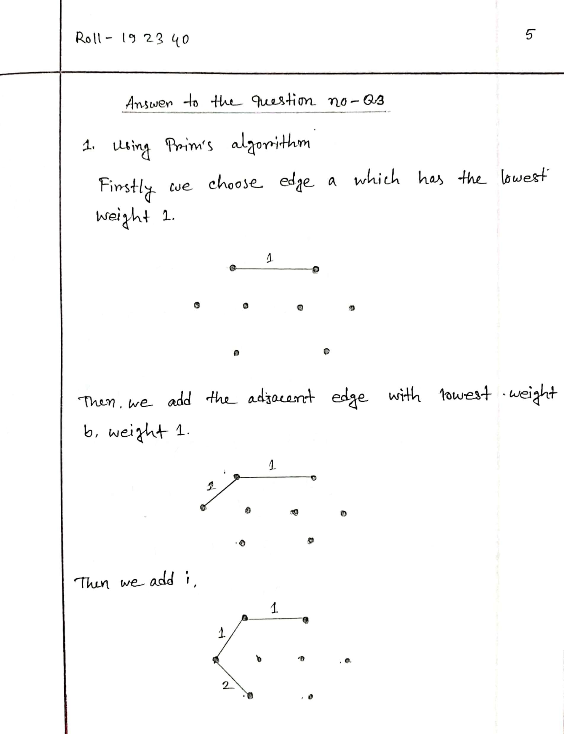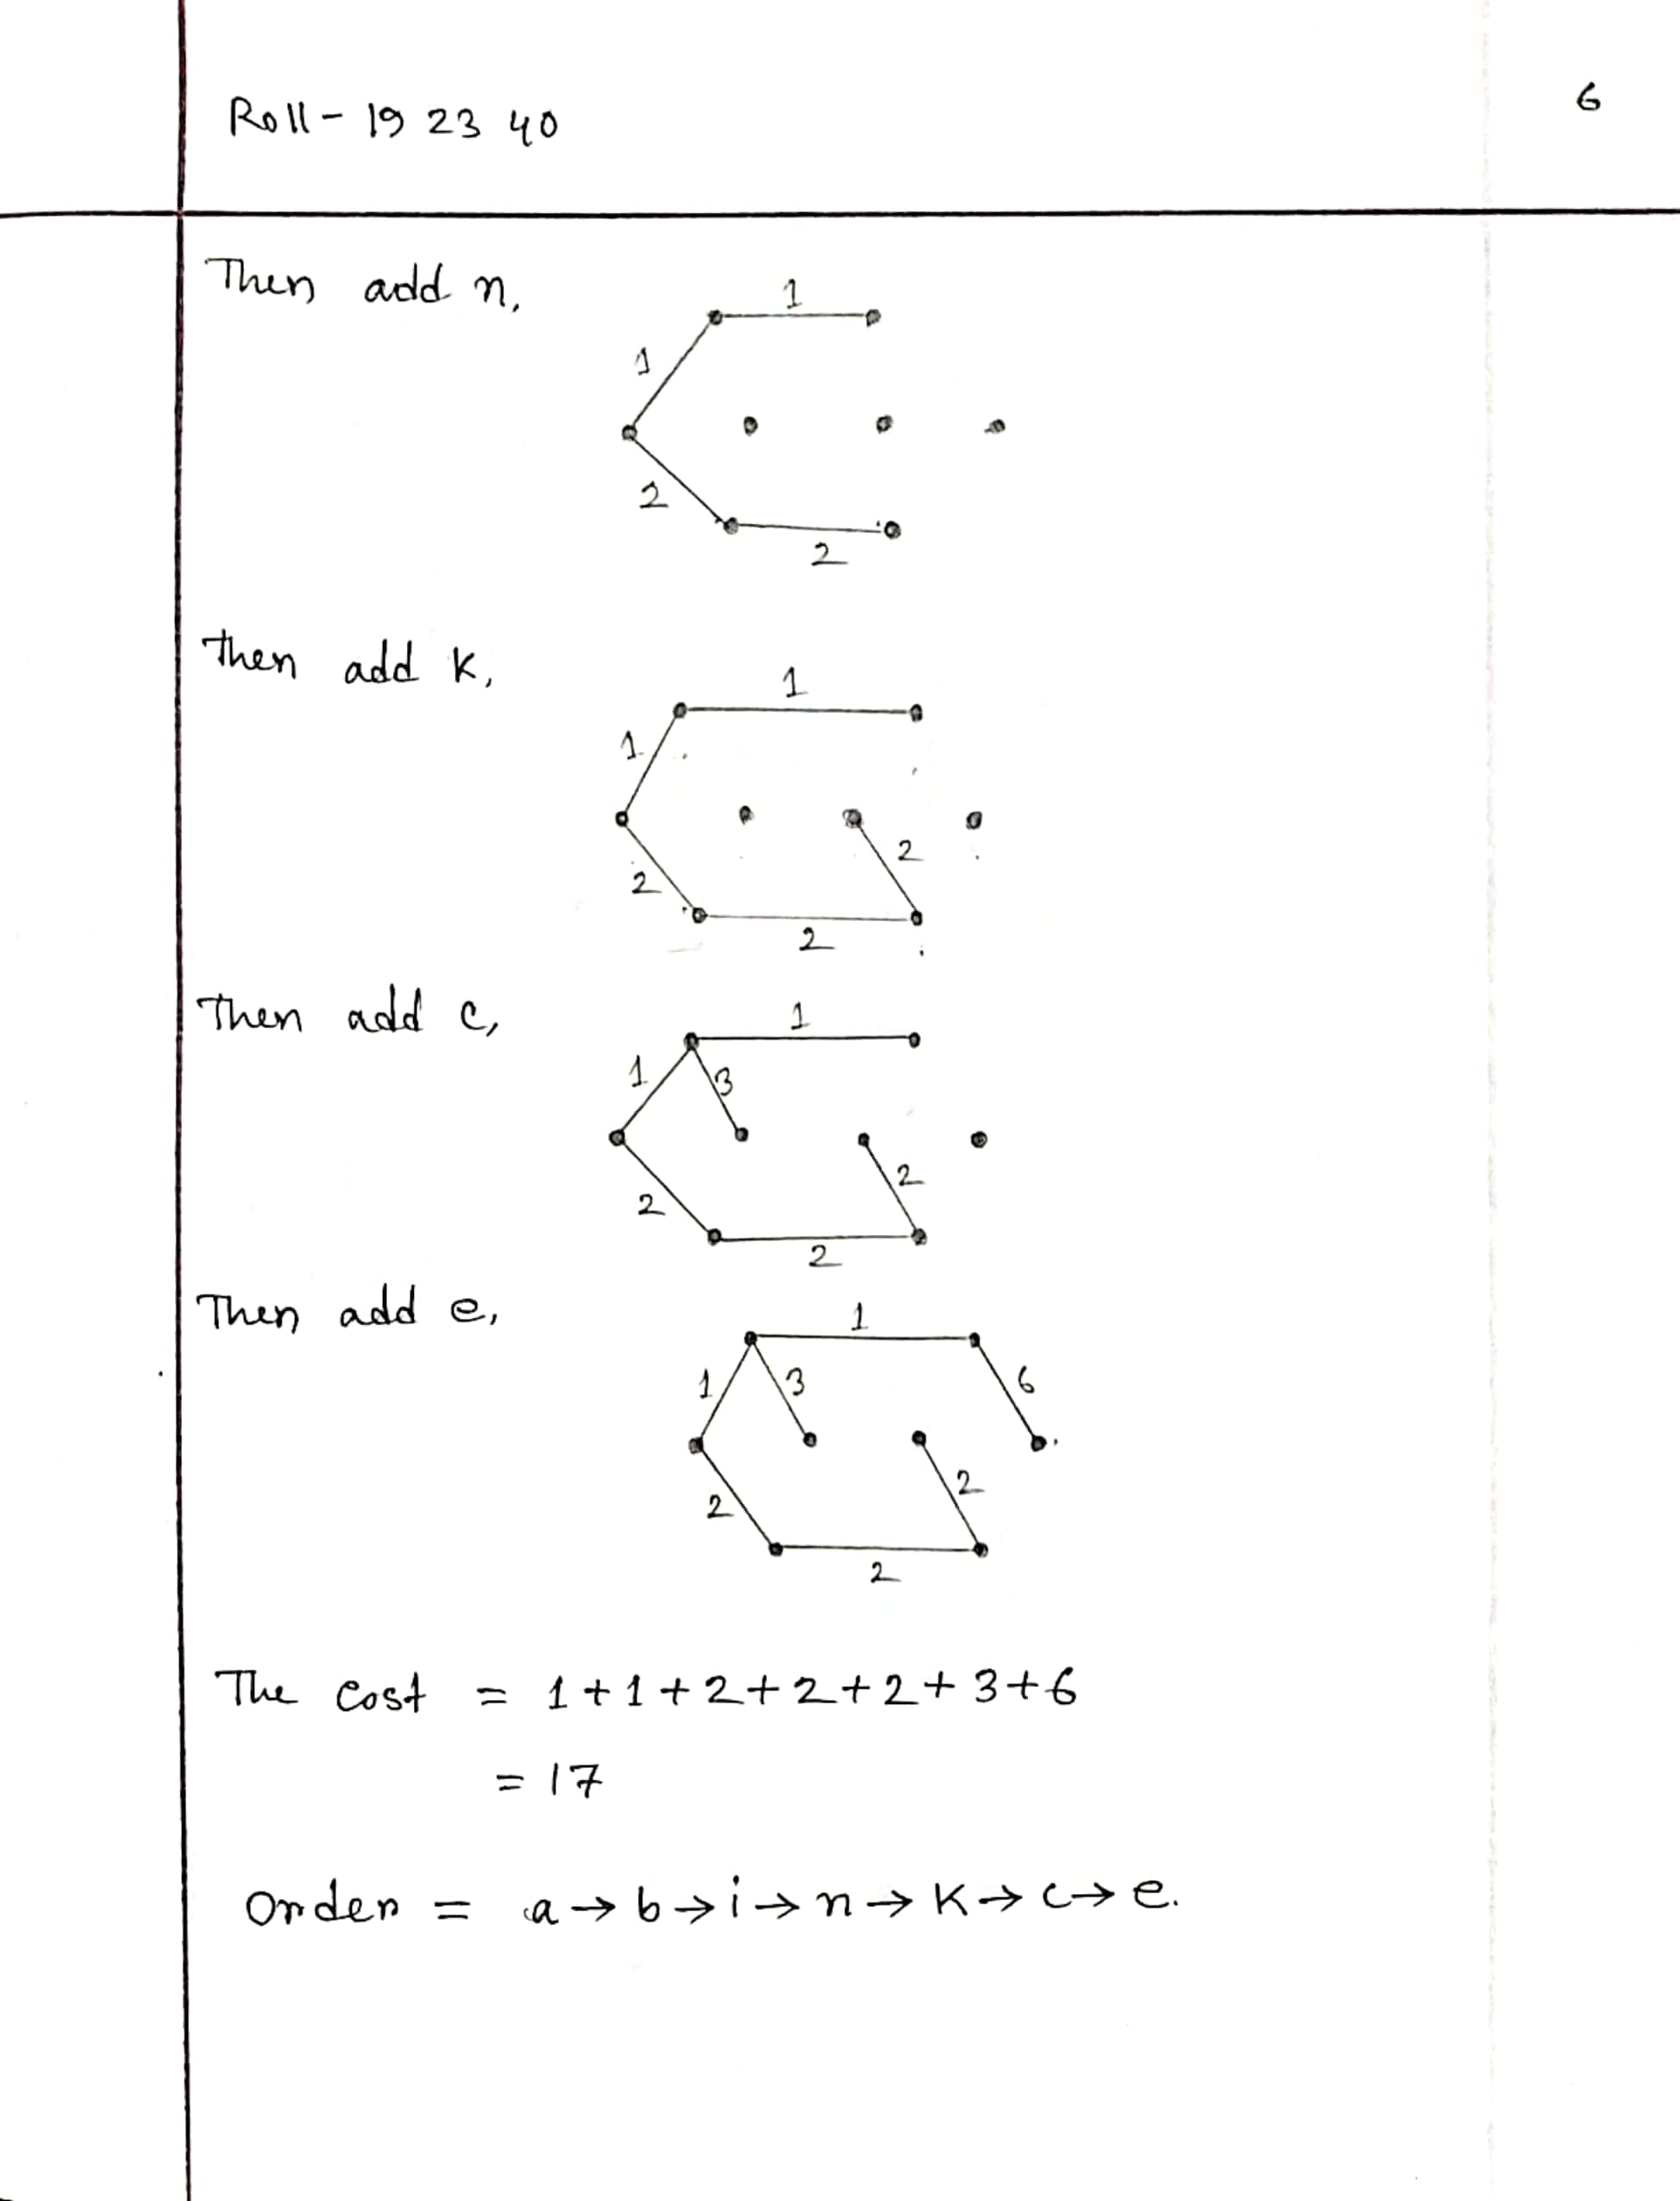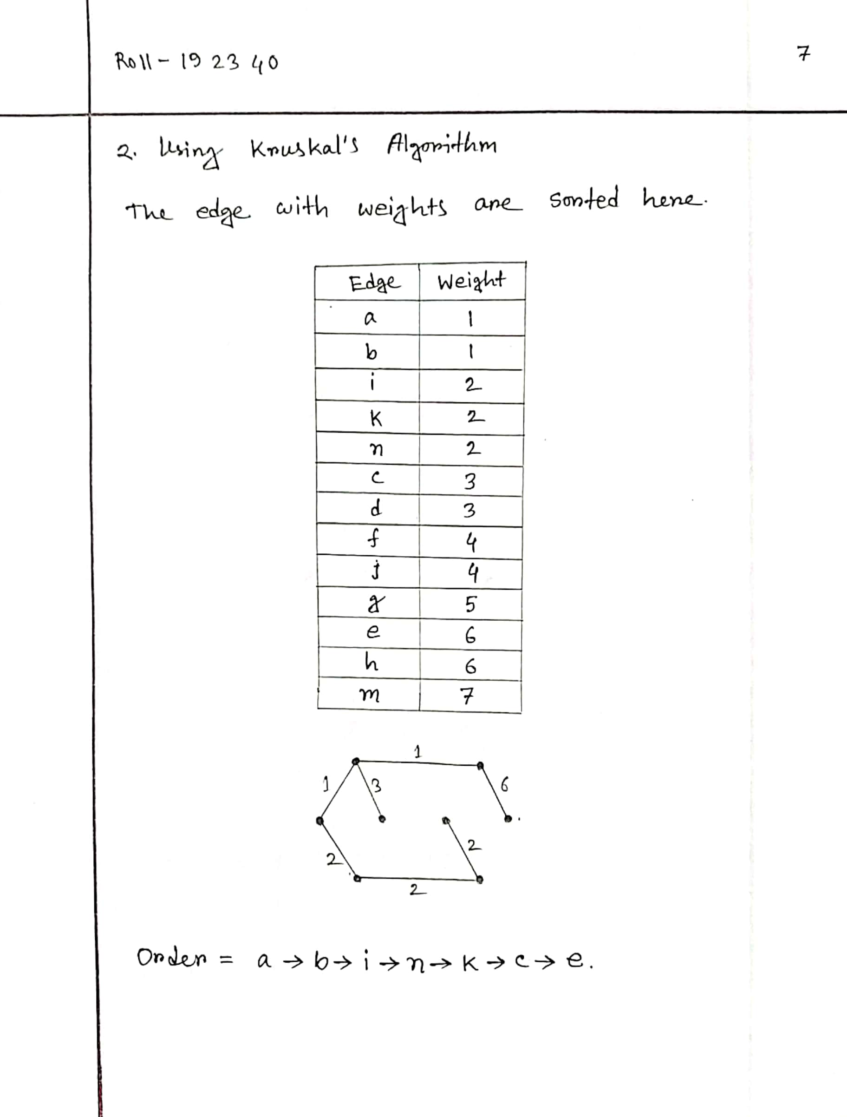

**THE END**